**Global Adaptation Index™ Technical Document**

This document describes the structure of the Global Adaptation Index™ (GaIn™). It explains how and why indicators were chosen to measure both a country’s **vulnerability** to the impacts of climate change and other global trends and its **readiness** to implement adaptation solutions. It also shows how the indicators are combined to produce the overall score and the individual measures of vulnerability and readiness.

As described in detail in each section, each axis has a distinct logical structure. Much of this difference is determined by the sourcing of data. Vulnerability indicators are gathered from data sources with no explicit structure for determining country vulnerability and a logical framework was developed. For the readiness score, the sources from which the majority of indicators have been selected are organized to explicitly address a country’s readiness to decrease vulnerability through the ability of its private and public sectors to absorb additional investment resources and apply them effectively. Thus, for readiness, we have tried not to reinvent the structures for economic and governance indicators, factors pertinent to the private sector, but utilize the work found in respected and long-lasting indices.

We have created a unique framework for the twenty-four vulnerabiltiy indicators, organized by three criteria:

* Sector
* Exposure, sensitivity and capacity
* Quantity and quality

For readiness, several well-known economic, governance and social indices were selected as candidates for inclusion in GaIn™. Similarly to the vulnerability indicators, these were chosen according to factors such as countries covered, years covered, public availability, credibility and “actionability". Forty-two indicators were chosen for final analysis and cross correlation, the majority of which came from four annually-published indices. After assessing the high degree of corrality between many indicators, the significant difference in time series made a few indices more attractive than others.

**[Excerpt of the Ranking]**

The vulnerability and readiness scores for each country are combined to produce two distinct results: a ranking and a matrix. To create a global ranking, the readiness score is subtracted by the vulnerability score. This combination is intended to show the overall preparedness of a country in protecting its citizens against the impacts of climate change and other global trends by using resources from the private sector. Such a ranking can clearly show how a country could move up or down the ranking by improving upon specific vulnerability and/or readiness indicators.

The matrix (Readiness Matrix) is a tool most useful for the private sector to make specific investment decisions based on their desire for risk and adaptation needs. A country in the upper right quadrant (high vulnerability and high readiness) would most likely be targeted by conservative investors whereas those attracted to risk might seek out opportunities in the upper left quadrant (high vulnerability and low readiness. To calculate a country’s position within the matrix, the vulnerability and readiness axis are weighted __ and __, respectively.

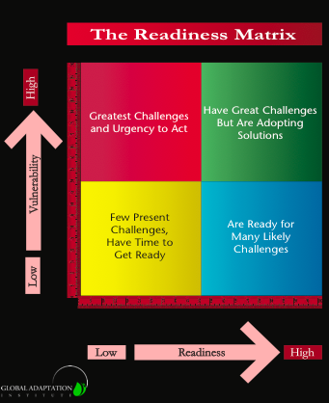

While the ranking and matrix do not convey the same information, they are related by the same underlying indicators and movements in one tool will result in movement in the other. For instance, movement up the ranking due to improvements in vulnerability could move a country from the upper left quadrant to the lower left quadrant. The exact same ordinal movement along the rankings, instead, due to improvement in readiness, would move this country from the upper left quadrant to the upper right quadrant.

Here we present an aggregation of static data. However, we will be able to provide a dynamic model that can show change over time; roughly 15 years, from 1995-2011. For countries with missing data for more than two years, we use linear interpolation. If only one data point is missing [someone write out the 3 % penalty, and I will help rewrite if needed].

When no data is reported, we check for obvious explanations (e.g. a country lacks any coastline).